Development Project I (420-K40-HR)
Assignment 01 – Technical Investigation & Client Meeting

Date assigned: Monday, September 12, 2024
Date due: Final Due Date September 26, 2024, before midnight
Part A – Sept 17 2024, before midnight
Part B – Sept 19 2024, before midnight
Part C – Sept 26 2024, before midnight
Late submissions will not be accepted without prior written approval.

Contents
Part A Section 1 - Skill Set inventory and gap analysis 2
Part A Section 2 - Technical research – legacy projects 3
Part A Section 3 – Authorization and Authentication 4
AMS – Part 1 4
AMS – Part 2 5
Part A Section 4 – Technology Decisions 6
.NET Framework vs .NET Core 6
Webforms vs MVC 6
Reflect 7
Part B Section 1 – Dependency Injection 9
Part B – Testing with Mock objects 10
Part C Section 1 - User Meeting 13
Part C Section 2 – Elevator Pitch and User Stories 14
Appendix 1: Connecting your DevOps instance to Visual Studio 15
Visual Studio 2019 15

All student answers should be in blue text so it is easily identifiable by the instructor.

Learning Objectives

Upon successful completion of these tasks, the individual students will:
- Ramp up on common skills, frameworks and technologies that will be options in the architecture and design
- Practice navigating and accessing projects and source code repositories via Microsoft Azure DevOps
- Familiarize with existing projects to use as a basis for future design choices.
- Familiarize the student with the development environment, including Microsoft Azure DevOps, and Visual Studio.
- Introduce and Understand the concepts of Dependency Injection and Mock objects

Skill set:

Skill | Options | Skill Acquisition
Database options | Entity Framework (model first, database first, code first)  No entity framework  (hand coded Data Access Layer i.e. write your own CRUD or queries)  Other | Web
UI options | MVC  WebForms  Other | Web, Maintenance
AMS | Understand the current authorization and role management systems that you must integrate into | Later
.Net Framework | .net core, .net Framework | Web
TDD | Modern test methods  Talk about Acceptance-based TDD ( ATDD) as well. | Web/This assignment/later
Dependency Injection | Modern test methods | Web/This assignment/later
MOQ  (testing with mock) | Modern test methods | Web/This assignment/later

Thoroughly read this assignment. Read it alone and then compare your notes with your teammates after you’ve done a full review of the assignment. Coordinate your shared activities and plan those tasks on the Azure DevOps task board for your team.

Part A Section 1 - Skill Set inventory and gap analysis

Using the Skill set table (above) as a starting point.

Hint: Don’t Panic. You’re not expected to be an expert on all this technology. At the beginning of the project, it’s important to know the skill gaps that need to be filled for the project. This is just an inventory and analysis.

Add another column to indicate your experience in each skill in terms of person weeks. (i.e. if you have done 2 weeks of MVC, 8 weeks of WebForms).

Add any other rows in terms of skills/infrastructure/frameworks you think you’d need for implementing any of the projects.

Skill | Options | Current skill level (person weeks per option) | Concerns/risks
Database options | Entity Framework (model first, database first, code first)  No entity framework  (hand coded Data Access Layer i.e. write your own CRUD or queries)  Other | 30 weeks | none
UI options | MVC  WebForms  Other | 30 weeks | none
AMS | Understand the current authorization and role management systems that you must integrate into | 1 week | Getting them to work given new Quebec laws. Also implementing one that is being built as the project goes on
.Net Framework | .net core, .net Framework | 30 weeks | none
TDD | Modern test methods  Talk about Acceptance-based TDD ( ATDD) as well. | 20 weeks | none
Dependency Injection | Modern test methods | 2 weeks | none
MOQ  (testing with mock) | Modern test methods | 0 weeks | Might be a struggle to learn how to use it.

Add any other general concerns/risks about any of the projects in general:

Part A Section 2 - Technical research – legacy projects
Before you start any new project, you can benefit from understanding projects that came before you so that you can learn/copy/steal their best practices.

The Computing Science department’s DevOps instance can be found at this local URL:
https://csazure.cegep-heritage.qc.ca:8080/

Note that this system is not accessible via the Internet (aka remotely), and you will need to use the VPN to access it from home or outside of the campus network.

Find the following projects and fill in the following table:
Project | URL | Programming Language | UI (WebForms/MVC) | Code snippet for AMS authentication/authorization  (provide source code filename and line number as well as code snippet) | Demonstrated DevOps / VS download and compile
NST | https://csazure.cegep-heritage.qc.ca:8080/NST/NST | C#, JS, HTML, CSS | MVC
CES | https://csazure.cegep-heritage.qc.ca:8080/CES/CES | Visual Basic, JS, CSS | WebForms
HERS | https://csazure.cegep-heritage.qc.ca:8080/HERS/HERS | C#, JS | WebForms
AMS | https://csazure.cegep-heritage.qc.ca:8080/AMS/AMS | C#, JS, HTML, CSS | MVC

For the projects, you may run and deploy locally from Visual Studio, but be sure to use the csdev databases. You may have to change the connection strings.

Note: For each project:
- Indicate the DevOps URL
- You must demonstrate to the professor that you’ve been able to download, compile and view the code from the DevOps server in your Visual Studio environment.
- Analyze the code to complete the tables above.

Part A Section 3 – Authorization and Authentication

AMS – Part 1
Our goal is to understand AMS from a black box point of view at this point.
We will learn the details how to integrate it and how the code works later on.
Your prof will give a brief walk through and demo.
Your other source of information is :
- The Runbooks of the legacy projects will tell you how to configure the application
- There’s help built into AMS

http://cstest.cegep-heritage.qc.ca/AMS
login with username userad, password cs@123test!

All student answers should be in blue text so it is easily identifiable by the instructor.

Read and understand AMS-LoginService.docx, found in Moodle for this course under reference.
There is an error in the Use Case diagram of AMS-LoginService.docx, what is the error:
Answer:

The AMS Database, CS Systems, and External Systems are shown as actors instead of objects the system interacts with

Explain: What is the purpose of AMS? What benefit does it provide?

The purpose of AMS is to have a centralized login functionality that deals with authentication and authorization. The benefit it provides is improved security as instead of relying on each application to have adequate security we can rely on one system to have extremely good security

Explain: How is AMS integrated into each legacy Heritage CS application?

It gives each application a centralized authentication and authorization service, it deals with each applications roles, and it gives each application access to Heritage’s active directory

Explain: What are the two services provided by AMS to each Heritage CS application?

The 2 services are Authentication and Authorization. It deals with Authentication by using the username and password with the colleges active directory, and it deals with authorization by checking the username against the applications roles

Explain: Application, Roles and Users as modeled in AMS. How does it relate to Application codes and Role codes.

Application codes are assigned to each application which allows AMS to know which roles and users are part of each application. Each Role in a specific application is assigned a role code within AMS. Also, Each user has role codes in each application to define their permissions within that application.

Explain: How do the applications ensure that users are constrained to the Role configured on them within AMS?

AMS first authenticates the user using their username and password. It then checks the application code that is being used and uses the username to check for what role codes that user has. Based on those roles that the application receives from AMS it either lets the user do what they are trying to do if they have that role or it gives them an error if they don’t.

AMS – Part 2

All student answers should be in blue text so it is easily identifiable by the instructor.

Assume your team creates an application called “BeastApp”. The key users of the system are Teachers, Coordinators, Students and a new role “Beast Master”. Ron Patterson is the one and only Beast Master.

Explain: What steps would you take in AMS to configure BeastApp and ensure the correct types of users are configured?

I would go to the manage applications page and fill in the application code and application description fields. I would then go to the manage roles page and for the teacher, coordinator, and student roles I would go to the edit page and add both the application and the users for each. I would then go back to the manage roles page and fill in the fields for the new beast master roll and I would then go to the edit page and add it to the application and only add Ron Patterson as a user.

Part A Section 4 – Technology Decisions

.NET Framework vs .NET Core

Some of the legacy projects were implemented in .NET Framework, but MS has introduced .NET Core in recent years.
Investigate: Pros vs Cons of .NET Framework vs .NET Core
Create table below:
.Net Framework |  | .Net Core
Pros | Cons | Pros | Cons
Deeply integrated with Windows making it ideal for windows apps | Windows only meaning you can’t use it for Mac or Linux | Cross platform meaning you can make apps for Mac and Linux | Doesn’t work with some older technologies
Very stable and well documented | No longer being developed | Higher performance
Integrated with Visual Studio | Apps built with it are very large in size | Much more light weight
 | Less performant than .Net Core | Open source
 |  | Designed with the cloud and microservices in mind

Propose: Which would you prefer to use for a new project and why?

I would rather use .NET Core because it is what I am the most familiar with as I have been using it for the past 2 years. Furthermore, Microsoft has stopped supporting .NET Framework which means that at a certain point it will become obsolete and won’t be able to be maintained

Webforms vs MVC

Investigate: Pros vs Cons of WebForms vs MVC
Create table below:
WebForms |  | MVC
Pros | Cons | Pros | Cons
Automatically manages the state of control between posts | Tightly coupled with .NET Framework and IIS so not good for cross platform development | separation of concerns | More work for simple applications
A lot of libraries to handle states | Limited control of HTML and JS | Separation of concerns is good for testing | Manual state management
Rapid prototyping | Can bottleneck larger applications | Full control over HTML
 | Harder to unit test due to high coupling of logic and UI | Good for modern web development
 | Tight coupling of logic and UI

Propose: Which would you prefer to use for a new project and why?

I would rather use MVC because it is what I am the most used to and I have spent over 2 years using it now. Also, WebForms is out of date

Reflect

Return to your work done for Assignment 0

What were your teams’ top and most important answers for “What went well?”

Our team’s most important answer for what went well is that we communicated very well and we were always positive about everything. Having good communication allowed us to tackle any difficulties very quickly. It is also very easy during a project to only see the bad and the positive outlook that we had allowed us to stay motivated and to actually enjoy working both on the project and together as a team

What were your teams’ top answers for “What didn’t go well?”

What were your teams’ top answers for “What questions do you still have?”

Our team’s top answer for what question do you still have is that we wanted to see what the project would have looked like if we had more time. Personally, I think that given more time we could have fully fleshed out the system and made something that we were really proud of.

Summarize the key points from your meeting minutes document, here (K40_A0_Minutes.docx)

Project 1:
Allan wants a system that would allow teachers to create test cases and upload them. Students would then be able to see the test cases and upload files to run against them. The students and the teacher could then see if the test cases pass or fail. There would be an option to dynamically change the programming language and the teacher would have the ability to: set up a course, set up and instance of a lab, have a description for the lab and be able to change the language

Project 2:
Allan wants a system that would allow teachers to create a group of coding puzzles for students to solve. Puzzles are locked until the previous one is completed. The solution to the puzzle will always be a number or a string. You can code directly on the website or upload a file and if you get the answer wrong you can try again until you get it right. Can be done in multiple coding languages it would keep track of how many puzzles you’ve completed.

Refer to the lecture material, in class discussions, and WooFlash quizzes for the following answers:

What is a project to you?
To me a project is something that has an end goal and multiple steps that you are trying to achieve

What is a project, according to Prof Chris?
A group of people trying to reach a fixed goal

What is the total current rate of project failure in Software Projects, according to Historical Trends?
19%

What is the main advantage of Agile project management in terms of outcomes?
You can better predict outcomes and find issues in the projects quickly

What are the phases of the Software Development Lifecycle? (Hint: there are 6)
Analysis, planning, design, development, testing, deployment, maintenance

What is a key client protocol in K40 and general projects regarding communication?
Communicate quickly and regularly

What is true about AI tools, in this program and course?
They can be helpful but also copying from them is plagiarism

What were Chris’ “Protips” in the Prezi presentation that you reviewed for homework?

To submit

Upload this completed document, UName_K40_A1A.docx, to Moodle with the answers filled in. i.e. celliott_K40_A1A.docx. Submit this one day before the deadline, if possible, to avoid technical or user errors.

Part B Section 1 – Dependency Injection

On Moodle there is a sample MVC solution “HeritageCollege .NET 6 Target.zip”.

See this tutorial for samples and hints on how to implement dependency injection.

Load the solution “HeritageCollege”

Change the Student Controller to take in a IStudentRepository as a constructor.

Write out here the steps you had to do and explain each line (why are you doing this):

- In Startup.cs add the IStudentRepository and StudentRepository to the scope of the services
  - This allows the controller to use the repositories for data access
- Make the IStudentRepository a public class
  - The controller is a public class so it cannot depend on a class that is less accessible
- Make a private readonly instance variable of type IStudentRepository in the StudentController called _myRepo
  - This creates an instance variable to be used for dependency injection
- Add a parameter of type IStudentRepository to the StudentController constructor called repo
  - This injects the dependency
- In the constructor make _myRepo equal to repo
  - This lets the methods in the controller access the repository

Explain, what is the benefit of using Dependency Injection on the controller?

Now the controller follows the SOLID principles, it is more loosely coupled, and it can be more easily tested

Explain the different between the Singleton, Transient and the Scoped service lifetimes.

A singleton is created once and then used across the entire application whilst a scoped service is created once per request and the same instance is used within that request, and a transient services in created every time it is requested

You just created dependency injection on construction, what are all the types of dependency injection?
Constructor injection in which the service is given through the class constructor, property injection in which the service is given through a public property of the class, and method injection in which an interface is made to give the dependency its methods and the interface is used with the client class

Show an example of each highlighting the precise line that the dependency injection is happening.

Constructor injection

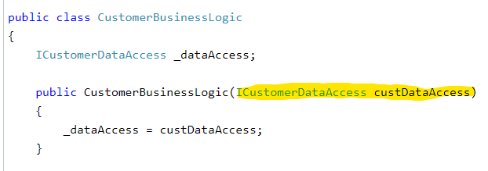

Property injection

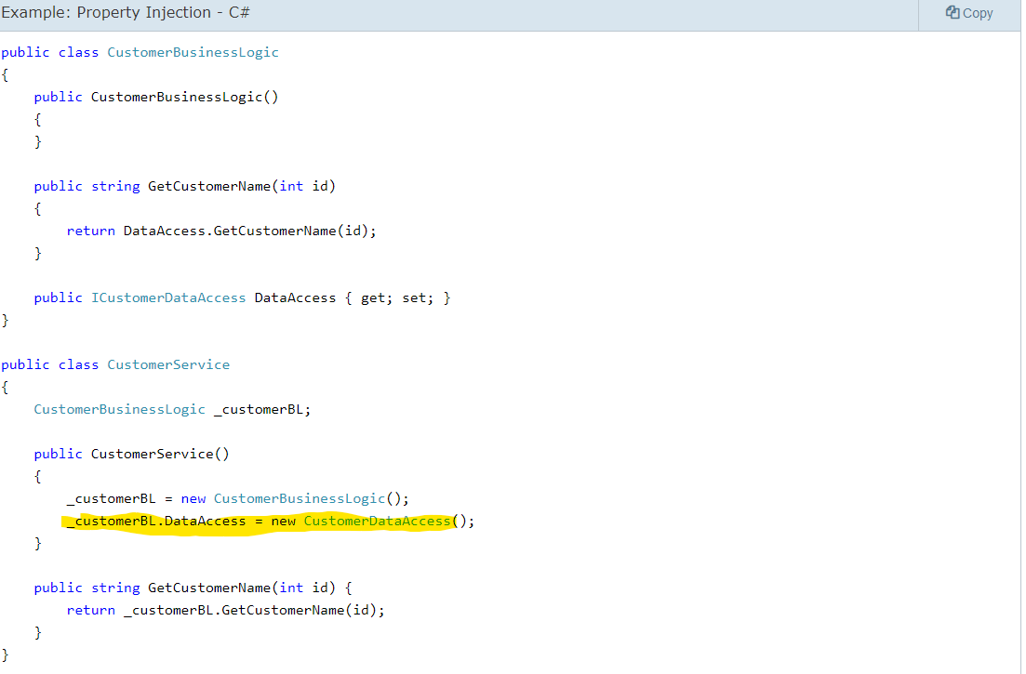

Method Injection
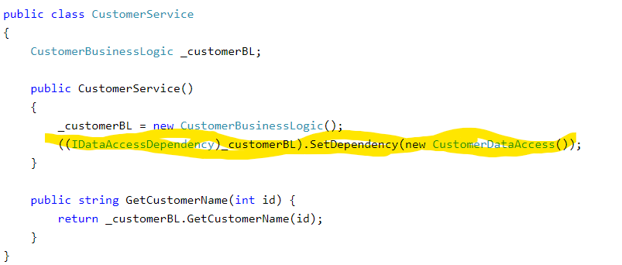

Further reading: link

Part B – Testing with Mock objects

This section continues with the HeritageCollege solution used in Part A.

Add->New Project->Unit Test Project, “HeritageCollegeTest”
In HeritageCollegeTest, select Dependencies, right click, Add Project Reference , under projects/solution select HeritageCollege.

Add a test for the StudentController
Rename UnitTest1 to StudentControllerTest
Add the HeritageCollege namespace

Add a test to just test the Index method:
[TestMethod]
public void TestIndexStudentRepo()
{
const int OUTPUT_OVERHEAD = 2; // output has 2 extra newlines
// Arrange
StudentRepository testRepo = new StudentRepository();
StudentController testController = new StudentController(testRepo);

// Act
string testOutput = testController.Index();

// Assert
// count lines of output
Assert.AreEqual(2+ OUTPUT_OVERHEAD, testOutput.Split('\n').Length);
// is Jean in there?
Assert.IsTrue(testOutput.Contains("Jean"));
Assert.IsTrue(testOutput.Contains("Richard"));
Assert.IsFalse(testOutput.Contains("Jose"));

}

- Show me a snippet of the test running successfully (screen capture of the test run results)

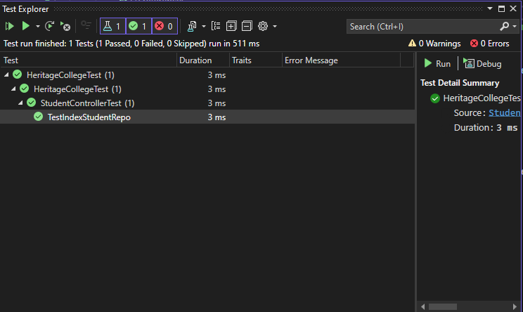

Test driven development: Write a test that fails first, then add code until it works.
Add a test to test the StudentController.GetStudent() (hint: it doesn’t exist yet).
[TestMethod]
public void TestStudentGet()
{
// Arrange
StudentRepository testRepo = new StudentRepository();
StudentController testController = new StudentController(testRepo);

// Act
Student testStudent1 = testController.GetStudent(1);
Student testStudent3 = testController.GetStudent(3);

// Assert
Assert.IsNotNull(testStudent1);
Assert.IsNull(testStudent3);

}

Pass 1: throw the not implemented exception, test fails
- Show me the output of the fail on the test run
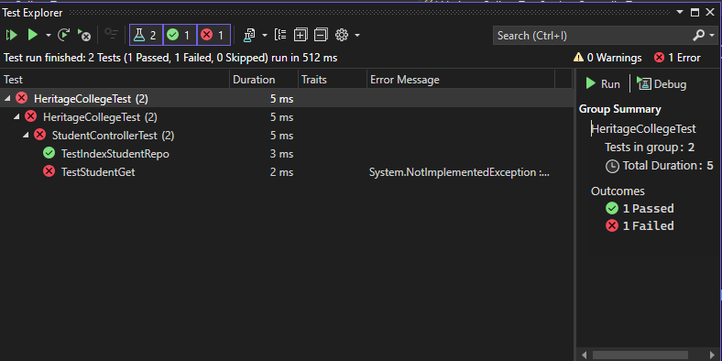
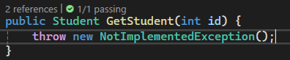
Pass 2: Implement the code so that the test passes

- Show me the output of the pass. Show me the code snippet of the updates in the Controller, IStudentRepository, and StudentRepository classes.
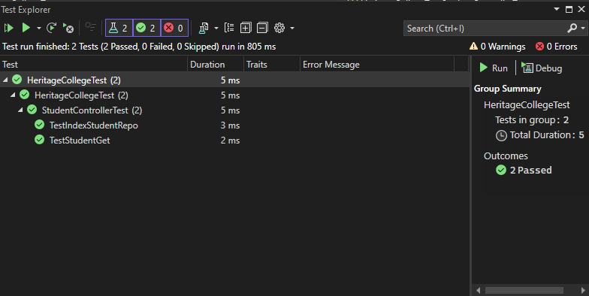
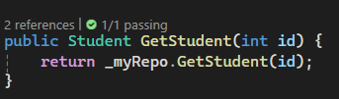
Build your own Mock.
Create your own new StudentRepository class, call it MyStudentRepository that implements the IStudentRepository, but under the hood, it only has 1 student in it (your name and studentId).
Create a new Unit test that uses MyStudentRepository, modelled like TestStudentGet() that validates the existence of studentId (yours) and one that doesn’t exist.
- Show the code for MyStudentRepository.
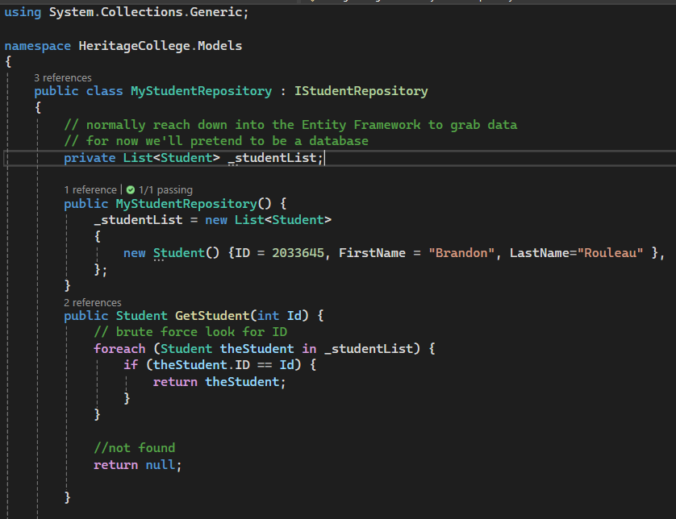
- Show the your test code
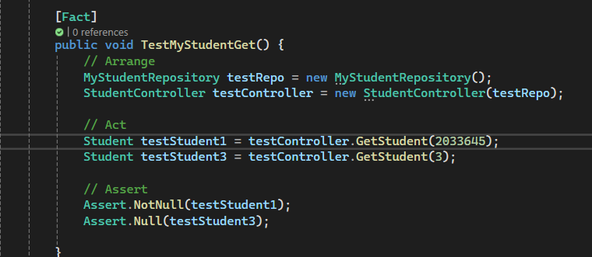
Congratulations, you manually created your own mock repository
(let’s pretend the original StudentRepository had fancy Entity Framework internals).

Now let’s see Moq in action.

Add the following unit test and ensure it runs. You may have to import/update the Mock package, for me, it was clicking through a wizard suggestion to fix.

// mocking the repository now
[TestMethod]
public void TestStudentGetWithMoq()
{
// Arrange
var testRepo = new Mock<IStudentRepository>();

testRepo.Setup(repo => repo.GetStudent(1)).Returns(new Student() { ID = 1 });
StudentController testController = new StudentController(testRepo.Object);
// Act
Student testStudent1 = testController.GetStudent(1);
Student testStudent3 = testController.GetStudent(3);

// Assert
Assert.IsNotNull(testStudent1);
Assert.IsNull(testStudent3);

}

- Show me the output of the test run. Everything should pass
- Your answer: 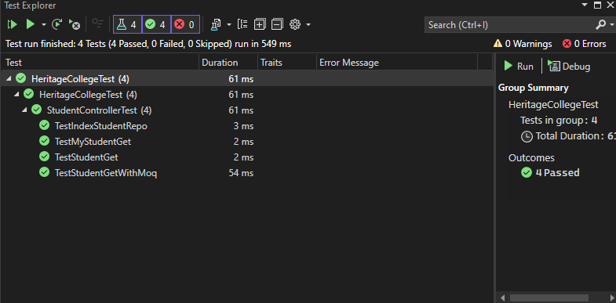

Your turn, create another test method that has a mocked repository with one entry (yours).

Validate you can get your studentId and the first name matches what you expect it to be.
- Show me the output of the pass. Show me the code snippet of the updates in the new test method
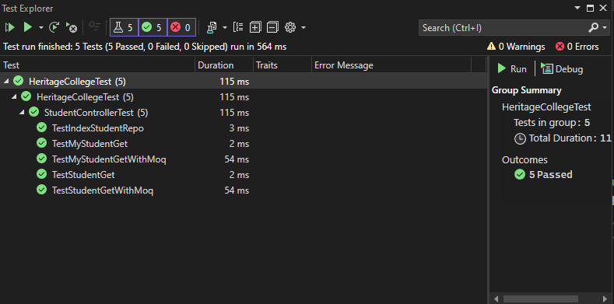
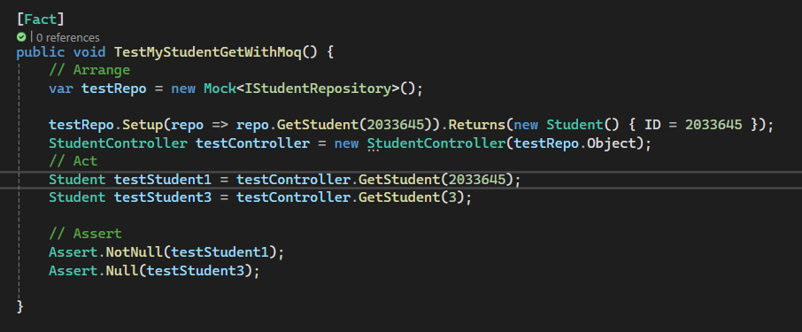

Further reading: link

To submit for Part B:

Upload this completed document, UName_K40_A1B.docx, to Moodle with the answers filled in.

- Ensure all of your student answers are in blue.
- Ensure you are submitting the right file.
- Download the file you uploaded to Moodle, check it for accuracy and completion. You are responsible for the accuracy and completeness of this file.
- Ensure you submit well in advance of the deadline to avoid any user or technical errors.

Part C Section 1 - User Meeting

Multiple clients will present their proposals for a project. We will also be calling these individuals our “users”. They are our most important stakeholder.

This User Meeting will take place during our lab session times. In the scenario that this cannot be accomplished, we will meet with our clients/users outside of class hours in a reasonable time that all students are available.

You are to capture minutes and analyze what was said (captured in a memo) and submit this before the above deadline.

- Take notes on the information gathered during the meeting with each user. In most cases, you’ll have one user/client In particular, focus on problems, user requirements, and priorities. Remember: we are problem solvers!

- Transcribe the notes (minutes of the meeting) into a Word document which indicates the day of your meetings (i.e. named YourUserName_K40_A01C_Meeting) and containing the following information for each meeting:
- An appropriate title
- Date and time (including both the start time and end time) of the meeting
- Place
- Attendees (list the full names of all the people who were in attendance in alphabetical order). Indicate who was the scribe (write the word “Scribe” after your name)
- Invited but did not attend (alphabetical list of full names)
- Subject (topic of the meeting)
- Items Discussed: The notes should include all the details of the user’s problems, requirements, and priorities based on what was discussed, and it should be written in a way that can be used as a reference by someone who was not in attendance. The notes can be in bullet format but should be written in full sentences.
- Decisions
- Action items – must have a description, owner, status (opened/closed) and due date
- Follow up and next steps

Tips for recording notes from a meeting:
- Don’t try to record notes word for word
- Organize your notes and write the minutes as soon after the meeting as possible while everything is fresh in your mind
- Add additional comments, or clarify what you didn’t understand right after the meeting
- Write in the same tense throughout
- Proof-read the document

Part C Section 2 – Elevator Pitch and User Stories

All student answers should be in blue text so it is easily identifiable by the instructor.

Write a business memo addressed to the professor/project manager.
For the project discussed in the User Meeting, analyze and:

- State the elevator pitch (same format as Inception Deck) for the project as you see it.
- Identify all the roles/actors/stakeholders with a brief description
- Provide User Stories for each type of system actor

Notes:
- Since this is an initial list, the user stories should not be detailed, as many of them will be further broken down into smaller user stories as the chosen project(s) progresses. Do not include any technical details.
- The standard user story format in Heritage CS Projects is the following:

As a <type of system actor/user>, I want <some goal> so that <some reason>.

Remember that <some reason> is from the point of view of that system actor, not you, the designer/developer.

To submit

When you have completed the assignment, upload a zip file YourUserName_K40_A01C_Px.zip to Moodle with the following contents (See Moodle for precise submission deadline.). Px where {x = 1,2,3,4,5} the project number you’ve been assigned.
- YourUserName_K40_A01C_Px_MeetingMinutes.docx meeting minutes.
- YourUserName_K40_A01C_Px_UserStories.docx for user stories.

Appendix 1: Connecting your DevOps instance to Visual Studio

See the following up-to-date documentation
Link

Visual Studio 2019
- Select the Manage Connections button in Team Explorer to open the Connect page. Choose Connect to a Project to select a project to connect to.

Connect to a Project shows the projects you can connect to, along with the repos in those projects.

- Select Add Azure DevOps Server to connect to a project in Azure DevOps Services. Enter the URL to your server and select Add.

- Select a project from the list and select Connect.

